**DAILY ONLINE ACTIVITIES SUMMARY**

|  |  |  |  |  |  |  |  |
| --- | --- | --- | --- | --- | --- | --- | --- |
| **Date:** | **14-06-2020** | | | | **Name:** | **B.A.SOHANKUMAR** | |
| **Sem & Sec** | **4TH SEM A** | | | | **USN:** | **4AL18CS013** | |
| **Online Test Summary** | | | | | | | |
| **Subject** | | **----** | | | | | |
| **Max. Marks** | | **----** | | **Score** | | **----** | |
| **Certification Course Summary** | | | | | | | |
| **Course** | **DATA SCIENCE WITH PYTHON** | | | | | | |
| **Certificate Provider** | | | **GLA** | **Duration** | | | **11.2 HOURS** |
| **Coding Challenges** | | | | | | | |
| **Problem Statement: Write a c program to remove specific character in a string.** | | | | | | | |
| **Status: EXECUTED** | | | | | | | |
| **Uploaded the report in github** | | | | **YES** | | | |
| **If yes Repository name** | | | | **LOCKDOWN CODING** | | | |
| **Uploaded the report in slack** | | | | **YES** | | | |

**CERTIFICATION COURSE DETAILS:**

Course:Data science with python

Completed topics are Models and Maths for Linear Regression,Relationship between Independent variable and Target variable,Coefficient of Correlation,Variance and Co efficient of Determinant,Linear Regression Assumptions,Advantages and Disadvantages,Data pre processing demo.

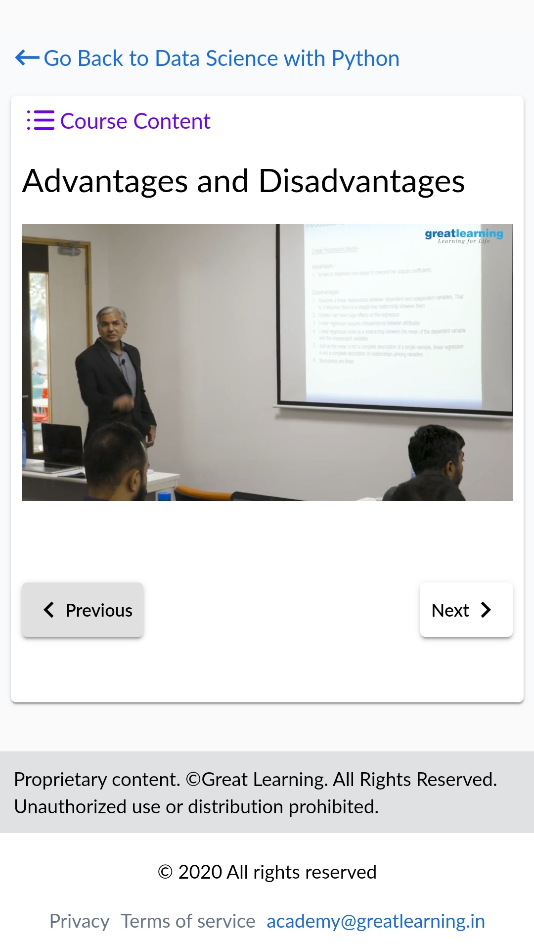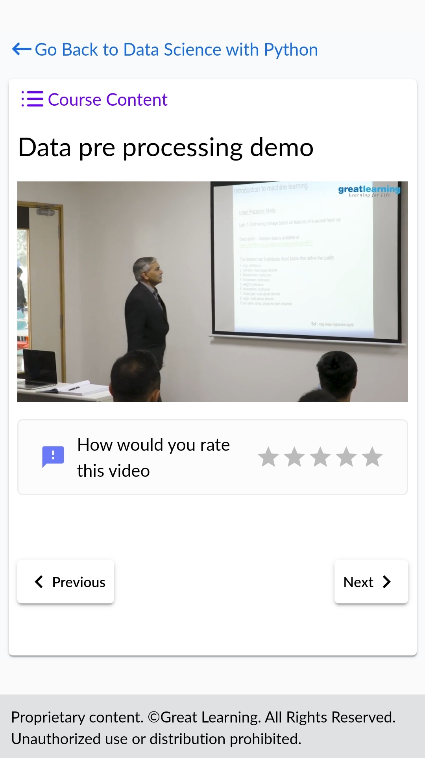

**CODING CHALLENGES DETAILS:**

1.Write a c program to remove specific character in a string.

Input:First line read a string

Second line read key character to be removed.

Output:String which doesn't contain key character

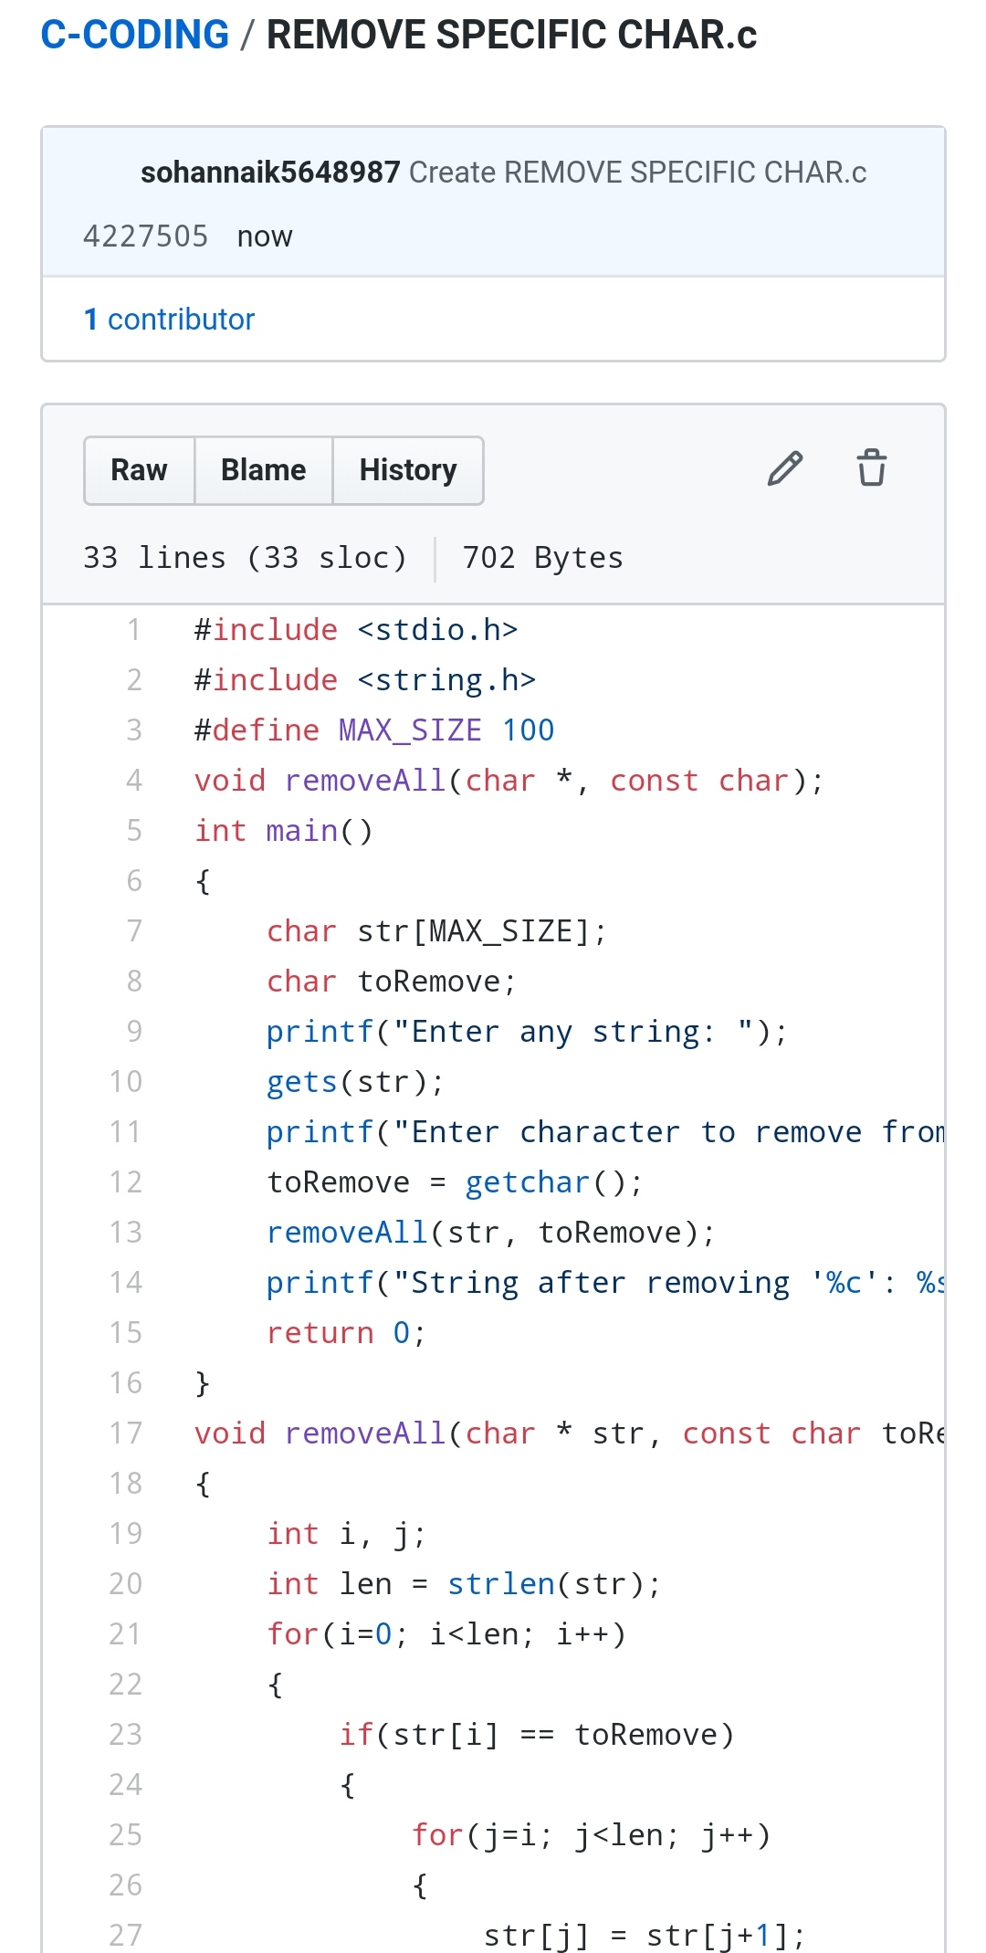

REPOSITORY LINK:https://github.com/sohannaik5648987/C-CODING